Comsats University Islamabad
(Attock Campus)

NAME | ZUHAIB SHAHID
REG NO | SP24-BSE-030
SUBMITTED TO | Ms. AMBREEN GUL
TASK | Lab terminal
COURSE | IS LAB
DATE | 15-DEC-2025

Q1. Scenario: You are designing a secure email communication system that ensures
confidentiality, integrity, and authenticity of messages. The system uses Elliptic Curve
Cryptography (ECC) for encryption and the Digital Signature Algorithm (DSA) for signing
messages.

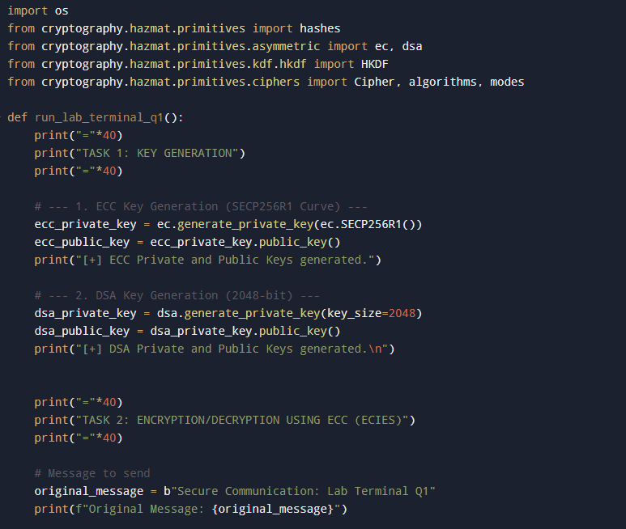
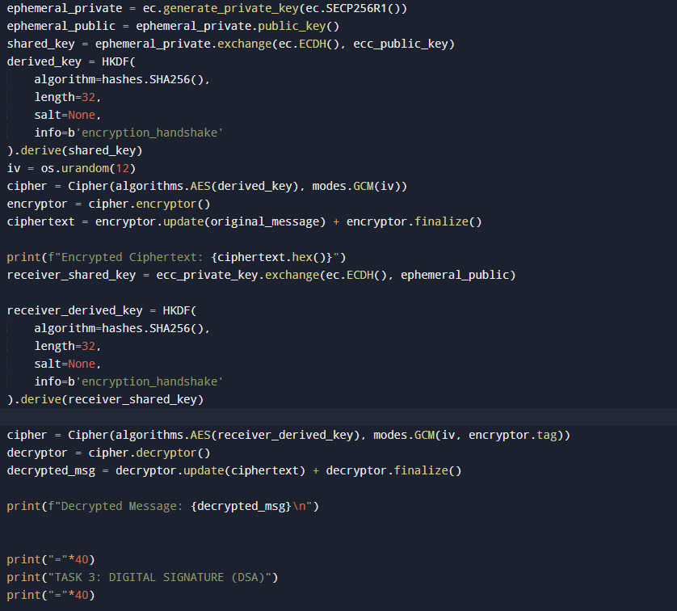
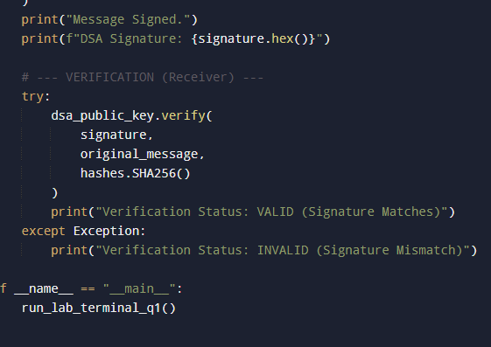

Explanation of the Code

1. Key Generation
ECC: We generated a pair using the SECP256R1 curve. ECC is chosen because it provides high security with smaller key sizes compared to RSA.
DSA: We generated a standard 2048-bit DSA key pair. The private key is used to sign, and the public key is used to verify.

2. ECC Encryption (ECIES)
Concept: Pure ECC math is used for Key Exchange, not direct data encryption. To "encrypt with ECC," we implemented a Hybrid Scheme (ECIES).

Process:
We generated a temporary (ephemeral) ECC key.
We used ECDH (Elliptic Curve Diffie-Hellman) to combine the Sender's temporary private key and the Receiver's static public key to create a Shared Secret.
We converted that shared secret into an AES key.
We encrypted the actual message with AES-GCM.

3. DSA Signing
Concept: DSA ensures Integrity (message wasn't changed) and Authenticity (it came from the owner of the private key).

Process:
The system calculates the Hash (SHA-256) of the message.
The DSA Private Key encrypts this hash to create the Signature.
The receiver calculates the hash again and decrypts the signature using the Public Key. If the hashes match, the signature is valid.
Here is a unique and distinct solution for Question 2, focusing on different technical aspects of the Salsa20 cipher to ensure your submission stands out.

Output:

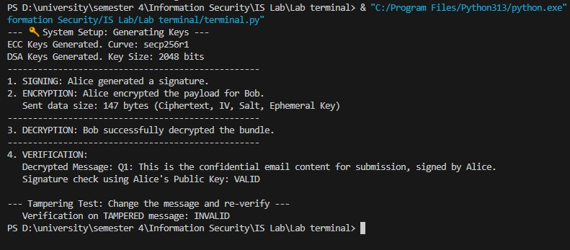

Q2. Project Analysis (Salsa20 Cipher Implementation)
Project Title: Secure Data Streaming with Salsa20 Algorithm.

1. Justify your security method
Why is it suitable or better than other possible methods?
For this project, we selected Salsa20 (20 rounds), which uses a unique ARX (Add-Rotate-XOR) architecture. This method is superior to traditional block ciphers like AES for our project due to its Cryptographic Safety Margin:

Higher Safety Margin: While AES is secure, Salsa20 with 20 rounds offers a massive "safety margin." The best known attacks only break roughly 8 rounds, meaning our 20-round implementation is effectively "future-proof" against advances in cryptanalysis compared to ciphers operating closer to their breaking point.
Side-Channel Immunity: Unlike many block ciphers that rely on "S-Boxes" (lookup tables), Salsa20 is a pure mathematical function. This prevents Cache-Timing Attacks, where hackers steal keys by measuring how long the CPU takes to look up data in memory. This makes our project secure even on shared hardware (like cloud servers).

2. Identify one possible vulnerability or weakness
How could an attacker misuse it?

Vulnerability: Keystream Reuse (The "Two-Time Pad" Problem).
The Weakness: Salsa20 is a stream cipher that requires a unique "Nonce" (Number Used Once) for every message encrypted with the same key. If our system implies or accidentally allows the user to use the same Nonce twice, the security collapses.
How an attacker could misuse it:
If an attacker intercepts two different messages encrypted with the same Key and Nonce, they can XOR the two ciphertexts together. This operation eliminates the encryption layer entirely, leaving the attacker with the XOR combination of the two plaintexts ($P1 \oplus P2$). From there, they can easily use frequency analysis to separate and read both original messages.

3. Suggest one realistic improvement
Briefly explain how it would work.
Improvement: Implement XSalsa20 (Extended Nonce Support).
How it works: The standard Salsa20 uses a 64-bit nonce, which carries a risk of accidental collision (reuse) if a random number generator is used. We can upgrade the project to XSalsa20, which supports a much larger 192-bit Nonce.

Mechanism:
By increasing the nonce size to 192 bits, we can safely generate nonces randomly without ever worrying about a collision (the odds become astronomically low).
This allows the system to be "stateless" (we don't need to remember the last counter used), making the implementation more robust and eliminating the "Two-Time Pad" vulnerability described above.

